PROJECT NAME: AJIO

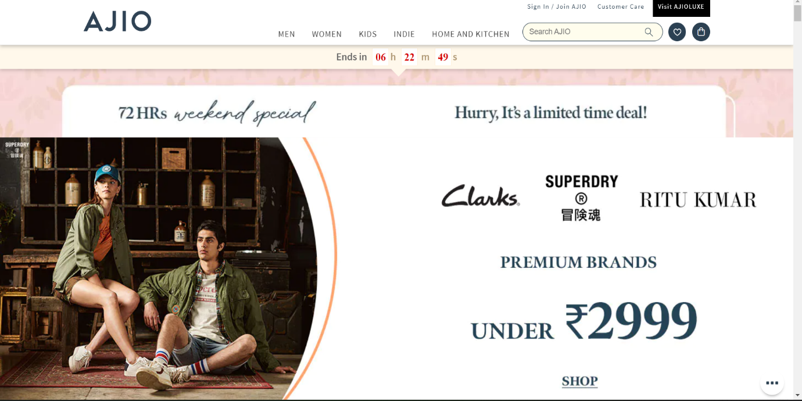

* **OVERVIEW:** It’s an e-commerce website for fashion wear, from fashion A TO Z everything is available under the same roof.

1. **HOME PAGE:**

#LOGO

# ICONS - (WISHLIST, ADD TO CART)

# SEARCH BAR

# SLIDERS WITH ARROWS - (IMAGES)

# DEALS - (IMAGES)

# FEATURED - (IMAGES)

# TRENDING - (IMAGES)

# FOOTER – ( CONTACT US, HELPLINES, BRIEF DESCRIPTION

ABOUT THE COMPANY, SOCIAL MEDIA HANDLE

ICONS, LINK TO JIOMART, )

1. **REGISTRATION FORM:**

# E-MAIL ADDRESS

#PASSWORD

# SHOPPING PREFERENCE

**3. MAIN PAGE:**

# FILTERS - ( BRANDS, COLOR, DISCOUNT RANGE, PRICE

COUNTRY OF ORIGIN, MATERIAL, FEATURES,

FIT, OCCASION, PATTERN, RATING, SIZE,

TYPE, SORT BY: )

# IMAGES OF THE CHOSEN PRODUCT WITH DETAILS LIKE -

( BRAND, PRODUCT NAME, PRICE, DISCOUNT% ( IF

ANY ) )

# ON CLICKING THE IMAGE - (MULTIPLE IMAGES OF THE

THE PRODUCT WILL APPEAR FROM DIFFERENT ANGLES,

ZOOM IN, ZOOM OUT

# PRODUCT DESCRIPTION - BRAND, PRODUCT NAME,

PRICE, DISCOUNT% (IF ANY), SIZE CHART,

DELIVERY OPTIONS, PRODUCT

DETAILS , SIZE & FIT , MATERIAL & CARE ,

SPECIFICATIONS, RATINGS, CUSTOMER REVIEWS

WITH IMAGES (IF ANY )

# LOWER HALF OF THE PAGE - RELATED PRODUCTS

1. **PAYMENT PAGE:**

# ADDRESS SELECTION

# PAYMENT METHOD - (PHONEPE , GOOGLE PAY , BHIM UPI ,

COD , CREDIT/DEBIT CARD , NET

- BANKING , EMI , PAYTM)